 | The CAMECA IMS 7f and 4f-E7 Software user’s guide  Navigator  00 45 633 900 - Type 108 – Indice A
0000.doc

Index

Content

1. Overview 2
2. Terminology 2
3. Starting the Navigator program 3
4. Navigator window 3
4.1 General concepts of the Navigator 3
4.2 Main bar menu 4
4.3 File menu 4
4.4 Navigator program files 5
4.5 Holder menu 5
4.6 Sample menu 6
4.7 Tools menu 6
4.8 Sample holder synoptic 6
4.9 Analysis position coordinates – Axis systems 8
4.10 Stage motion 10
4.11 Preset positions 11
4.12 Sample configuration 12
4.13 Sample ID editor 13
4.14 Sample Type files 15
4.15 Sample alignment 16
4.15.1 Principle 16
4.15.2 Edit Alignment points 16
4.15.3 Tools > Sample Alignment 18
4.16 Holder alignment 19
4.16.1 Tool > Holder Alignment 19
4.17 Holder>load 20
4.18 Holder>unload 20
5. Edit Holder mode 21
5.1 Main commands 21
5.2 Holder configuration edition 21
5.2.1 Holder edition (window configuration) 22
5.2.2 Holder edition (edit alignment) 24
5.2.3 Sample ID edition 24
5.2.4 Preset Position edition 24
6. Crater position list 25
7. Tools 25
7.1 Init stage 25
7.2 Logbook 25
8. Setup file parameters 25

Overview
The Navigator program is used to drive the sample stage along the three axes X, Y, Z. Note that the Z axis is available only in instruments equipped with the Z-axis option. Thus it allows the operator to navigate on the sample Holder presently loaded in the analysis chamber. The Navigator program also offers edition functions in order to define the name and the position of the samples loaded in the Holder, and preset analysis positions.
The main functions available in this program are :
- Definition of the sample holder configuration
- Sample ID edition
- Preset position definition
- Sample stage motion
- Holder and Sample alignment
- Analysis position logbook
Note : when the instrument is equipped with the rotating stage option, the Navigator program interface can be used to start and to stop the sample rotation.

Terminology
Holder represents an object which is used to bring samples to be analysed in the analysis chamber. There are different holder types which will be selected accordingly to the sample size, but all of them are designed as Holder in this document. These holders are equipped with Windows (holes) in which the samples are loaded. The size of these windows can vary from holder to holder and for the same holder. These different windows will taken into account by the Navigator program.
The Navigator program is divided in two main sections Navigation and Edition, and in both modes it is used a concept of present holder, present window or present sample.
- Navigation mode : dedicated to the navigation over the holder loaded in the analysis chamber.
- Edition mode : dedicated to the edition mode for defining the holder configuration , the sample ID's,…..).
In the Navigation mode,
- The present holder is the holder which is loaded in the analysis chamber.
- The present window is the window of the present holder which is in the analysis position (i.e. within the field of view the secondary ion optics)
- The present sample is the sample loaded in the present window.
In the Edition mode,
- The present holder is the holder being under edition.
- The present window is the window being under edition.
- The present sample is the sample being under edition

Starting the Navigator program
The Navigator program is started by clicking on the Navigator icon in the main bar menu located on the right hand side of the computer screen.
The first click loads the program in the memory. The icon turns from bleu to red. Then successive clicks open/close the main windows and associated dialog boxes of the Navigator program.
The user's interface of the Navigator program consists of two main windows represented in Figures 1 and 2:
Figure 1 : Navigator main dialog box  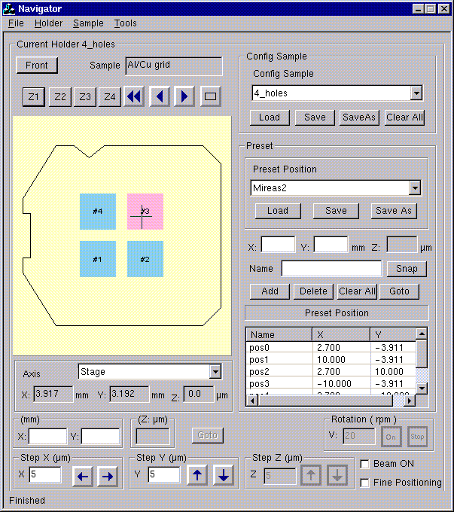 | Figure 2 : Edition dialog box  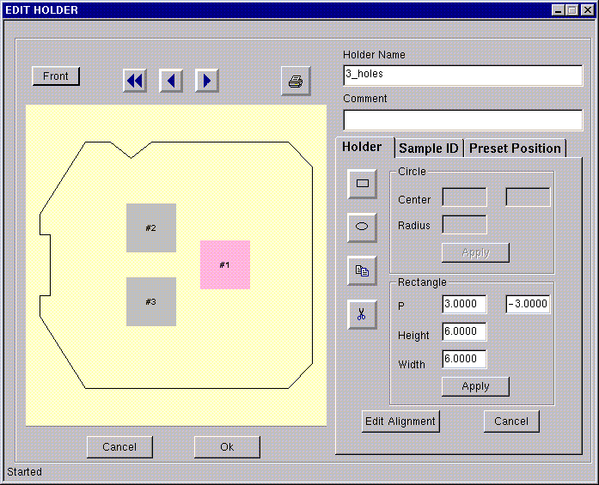

In these two windows there is a synoptic representing the present holder with its window configuration and samples loaded in it.

Navigator window

General concepts of the Navigator
The Navigator program allows to fully define the sample holder loaded in the analysis chamber by associating three different types of information :
- Sample holder configuration : it defines the size and the position of the windows present in the holder. A file system allows to save different sample holder configurations on the disk.
- Sample configuration : it defines the features (name, matrix…) of the sample loaded in every window. A file system allows to save different sample configurations on the disk.
- Preset positions : they are positions memorized by the operator. A file system allows to save different Preset position configurations on the disk.
When a sample holder has been loaded in the sample stage by the Load command, the sample holder comes with its last sample configuration. Once loaded the operator can change the sample configuration and the preset point configuration to be consistent with the targeted analyses.
Note that the software controls the consistency between sample configuration and sample holder configuration (i.e number of windows and number of samples) that the operator is attempting to associate.

Main bar menu
The main bar menu contains 4 main menus giving access to the functions listed hereunder :
File : Print, Remove, Exit
Holder : New, Save_as, Duplicate, Delete, Restore, Modify, Sort, Load, Unload
Sample :Edit_sample_ID, Copy_sample, Paste_sample, Delete_sample, Undelete_sample, Edit_pattern_mapping, Crater.
Tools : Init_stage, Holder_alignment, Sample_alignment, Logbook, Options.
The use of these functions is described in the following sections.

File menu
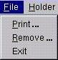
Print… : command to call a print manager. A dialog box opens for the print option selection. The operator can select to print : the holder synoptic, the sample list, the preset position list.
Remove… : command to call a tool which allows to manage the Navigator files (holder, preset positions….., See § Navigator files). The dialog box of this file manager is shown in Figure 15. Files can be deleted, copied, moved.
Figure 3: Navigator file manager
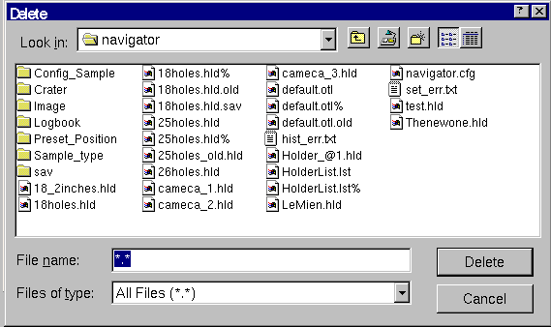
Exit : select this command to quit the Navigator program. Note that all information not saved will be lost.

Navigator program files
The Navigator program handles different files which contains the information defined by the operator. The hereunder table summarizes the different file types and where they are stored. All the files of the Navigator program are store in the directory Navigator. All of these files have the text format but image files with TIFF format.
File type | File extension | Directory
Sample holder | .hld | Navigator
Sample configuration | .spl | Navigator/Config_sample
Preset position | .prs | Navigator/Preset_position
Crater | .crt | Navigator/Crater
Sample type | .ptm | Navigator/Sample_type
Image | .tif | Navigator/Image
Logbook | .log | Navigator/Logbook
- Holder files : see § Edit holder
- Sample configuration files : see § Sample configuration
- Preset position files : see § Preset positions
- Crater files : contains the information relative to analysis craters sputtered in every sample. For every analysis run on a sample, the Navigator program stores the raster size and the position of the crater. There is one crater file per sample defined.
- Image files : contains the images of the alignment patterns. There is one file per pattern type.
- Sample type files : see § Sample type files
- Logbook : contains the information of the Analysis logbook

Holder menu
This menu gives access to all the commands used to perform the Holder definition. The list of these commands is given hereunder. See § Edit Holder window for more details.
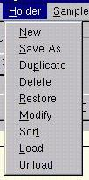

Sample menu
This menu gives access to the commands used to perform the Sample configuration definition. The list of these commands is given hereunder. See § Sample ID edition for more details.
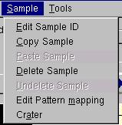
Edit pattern mapping : see § Sample type files
Crater : see § Crater position list

Tools menu
This menu gives access to the commands used to control the settings of the Navigator program. The list of these commands is given hereunder. See § Tools for more details.
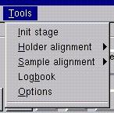

Sample holder synoptic
The holder synoptic is displayed in the light yellow graphic in both Edition and Navigation windows.
Inside this graphic area, there is a frame (continuous black line) which defines the contour of the sample holder, i.e the area which can be explored by the sample stage. Therefore, any window defined for a given holder must be defined within this frame.
The area covered by any window defined for a given sample holder is drawn in light grey color in the synoptic. When a sample is loaded in a window (sample_ID edited) the color turns from light grey into light blue.
When a window becomes the present window (i.e centred on the mass spectrometer axis) it turns into light red color.
This synoptic can handle rectangular and circular shaped windows. See § Holder edition(window configuration).
In the upper left corner of the Navigation window there are commands and information available about the sample holder as shown in Figure 3:
Figure 4: Information and control of the holder synoptic
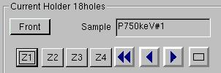
- Front / Back : the label of this button indicates the representation mode of the holder in the synoptic. The toggle between the Front/Back representation is made by clicking on this button. The representation change is made by means of a symmetry relative to the horizontal axis of the synoptic.
- Click on one of these 4 buttons allows the operator to change the magnification of the sample holder synoptic. Z1 corresponds to the lowest magnification (the synoptic represents the full sample holder), Z2 larger magnification (the synoptic represents the full current window). Z3 and Z4 are still larger magnification representation. Note that when zooming the synoptic, if the sample edited in the window is a CAMECA test sample (Ta/Si grid so-called MIREAS) the patterns are represented on the synoptic as shown in Figure 4.
Figure 5: Schematic representation of the Mireas samples in the synoptic
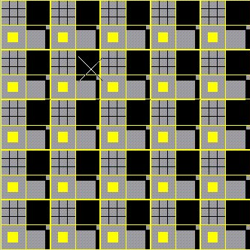
There are options for the information display in the synoptic. The option selection is performed in the menu Tools>Options…. The corresponding dialog box is shown in Figure 5.
Figure 6: Synoptic display options
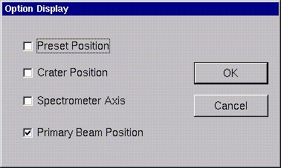
- Preset position : when checked, the preset positions are represented by green squares on the synoptic
- Crater position : when checked, for every analysis performed, there is a brown square marking the analysis position of the corresponding analysis.
- Spectrometer Axis : when checked, there is a marker on the synoptic indicating the current position of the mass spectrometer axis. When the sample stage is moved, the marker moves on the synoptic.
- Primary beam position : when checked, there is a marker on the synoptic indicating the current position of the primary beam position. When the sample stage is moved, the marker moves on the synoptic.
Note : in most of the cases the marker for the spectrometer axis and the marker for primary beam position are overlaid.

Analysis position coordinates – Axis systems
The analysis position is always determined by the mass spectrometer axis.
The operator can read the X and Y coordinates of the analysis position either on the Real time display screen or in the Navigator window. The Z position of the stage is displayed in the Navigator window only. Figure 6 shows the coordinate display in the Navigator window.
Figure 7: Display of analysis point coordinates and axis system selection.
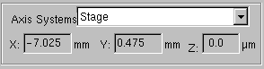
In the Navigator window, the operator can select different axis systems for the display of the X and Y coordinates of the current position. All of them use an X-axis and Y-axis respectively along the vertical and horizontal direction of the synoptic. The axis systems differ by the position of the origin only.
- Stage (O_{st}, X_{st}, Y_{st}): the origin is set at the zero of the X and Y motion of the stage.
- Holder (O_{h}, X_{h}, Y_{h}): The origin is set at the center of the Holder. This axis system can differ from Stage by an offset corresponding to a factory setting which is saved in the instrument set-up file.
- Window (O_{w}, X_{w}, Y_{w}): the origin is set at the center of the current window.
- Sample (O_{s}, X_{s}, Y_{s}): the origin can be set at any point over the sample surface (to be defined by the operator (see § Sample alignment).
- Local (O₀, X₀, Y₀): the origin is set at the current analysis position

Figure 8: Axis systems for analysis position coordinates
O_{st}
Y_{st}
X_{st}
O_{h}
Y_{h}
X_{h}
O_{w}
Y_{w}
X_{w}
O_{s}
Y_{s}
X_{s}
O_{o}
Y_{o}
X_{o}

Figure 9 : Axis system misalignments induced by load/unload operations
O_{st}
Y_{st}
X_{st}
O_{h}
Y_{h}
X_{h}
O_{s}
Y_{s}
X_{s}
O_{w}
Y_{w}
X_{w}

Note that in the case of a perfect mechanical system all of these axis systems would differ by a translation only. However, practically, both sample holder loaded/unload operations on the stage and sample loaded/unload operations into a sample holder can introduce misalignment between the different axis systems. Therefore when a accurate positioning is required, this misalignment must be measured and compensated by a software correction. The Navigation software offers tool to perform these alignments (see § Holder alignment and Sample alignment). Figures 7 and 8 summarizes the different axis systems and the misalignments which can result from load/unload operations of samples and holders, respectively.

Stage motion
From the Navigator window there are several ways for moving the sample stage :
- Click in the sample holder synoptic on the targeted new analysis point. The stage is moved in order to bring this point of the sample holder onto the mass spectrometer axis.
- Edit X, Y and Z in the dedicated editing fields and click on Goto. The stage moves to this new position. When moving to a new position, the operator can check the Z adjustment by clicking on the Autofocus button.
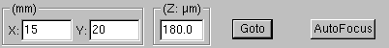
- Step by step motion. Enter the step size and click on the arrow. Every click move the stage by on step along X(left and right), Y(back and forth), Z(up and down)
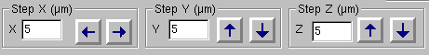
- Recall a preset point from the preset point list. (see§ Preset positions)
There is also “macro” functions to easily move easily from window to window and within a window
-  Click on these buttons moves the stage from the present window to the next one. (: previous, : next,  : first one)
-  Click on this button move the stage in order to bring the center of the current window onto the analysis position (i.e the mass spectrometer axis).
The stage motion is used to centre the analysis position onto the mass spectrometer axis. The resolution of the X and Y stage motion is 5µm. When a very fine analysis position centring is required (better than 5µm), the option Fine positioning must be checked. In that case the X and Y thumbwheels are no longer affected to the X and Y stage but affected to the DTR1 deflector. This deflector allows to adjust the mass spectrometer axis relative to the sample with a resolution better than1µm. Note that when “fine positioning” is selected, the stage is locked to its current position.
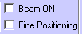
In order to avoid any unintentional sputtering of the sample surface, an automatic primary beam OFF is applied before moving the sample stage by means of any of the Navigator commands above described. The Beam ON option must be checked if it is required to leave the primary beam ON while moving the stage,.

Preset positions
In the Navigator program, the operator can defined series of preset points. These series can be saved in files in order to be recalled later on.
A preset point is defined by the 3 coordinate X,Y and Z and a name which is used for its identification.
Figure 9 shows the section of the Navigator window dedicated to the handling of the preset positions.
Preset position file combo box : this list is used to select the file name of the preset position series to be loaded. The current file name is shown at the top of the list.
Load : click on this button to load the preset file displayed in the combo box
Save : click on this button to save the modifications of the current preset positions series in the last loaded file. The previous file will be overwritten with no confirmation prompt.
Save as : click on this button to save the current preset positions series in a new file. There is a prompt to enter a new file name.
X, Y, Z : editing fields for defining a new preset point.
Name : editing filed to enter the ID of the new preset point. Two preset points cannot have the same ID in a given series.
Figure 10: Interface for the preset position handling in the Navigator window
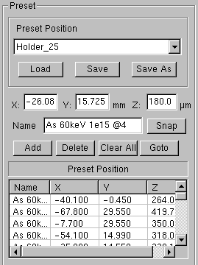
Snap : click on this button to copy in the X,Y and Z editing fields the current position of the sample stage.
Add : click on this button to add a preset point in the current series. Note that this function add the preset point in the current list but not in the corresponding file. A Save action is required in order to update the file. There is a confirmation while adding a preset point with an ID already existing in the list. The preset position are listed in the alphabetic order.
Delete : click on this button in order to delete the preset position selected in the list (blue line).
Clear all : click on this button in order to delete all the preset positions present in the list.
Preset position list : table displaying the current preset position series.
Goto : click on this button to move the stage in order to bring the selected preset point (blue line) onto the mass spectrometer axis.
Procedure to edit a new preset point :
- edit the XYZ coordinates. This can be done either manually or using the Snap function.
- Edit an ID (name)
- click Add
Procedure to Modify a preset point :
- Select in the list the preset point to be modified by clicking on the corresponding line
- Modify XYZ an ID (name) in the editing field
- click Add. Confirm the overwriting of the modified preset.
Procedure to delete a preset point :
- Select in the list the preset point to be deleted by clicking on the corresponding line
- Click Delete
Procedure to move to a preset point :
- Select in the list the targeted preset point by clicking on the corresponding line
- Click Goto

Sample configuration
Every sample holder can be associated to a Sample configuration. A Sample Configuration is a file containing the description of all the samples loaded in the Holder. Therefore, this file contains information on : sample name, matrix name, pattern alignment…...
Figure 10 shows the section of the Navigator window dedicated to the handling of the Sample configuration
Figure 11: Interface for the Sample configuration handling in the Navigator window
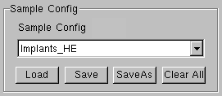
Sample config : combo box used to select the file name of the Sample Configuration to be loaded, or saved, or saved as.
Load : click on this button to load the sample configuration list displayed in the combo box
Save : click on this button to save the modifications of the current sample configuration in the last loaded file. The previous file will be overwritten with no confirmation prompt.
Save as : click on this button to save the current sample configuration in a new file. There is a prompt to enter a new file name.
Clear all : click on this button in order to delete all the samples defined in the current sample configuration.
When loading a new holder, this Sample configuration is updated according to the sample configuration status defined when the Holder definition has been saved.
Procedure to Save a new sample configuration file:
- Edit the samples loaded in the current Holder.
- Click Save as. A dialog box opens
- Edit the new file name and click OK.
- The new file name is displayed in the combo box

Procedure to Load a sample configuration file:
- Select in the combo box the file to be loaed
- Click Load

Sample ID editor
For every window of a given holder, the sample_ID can be defined from the Navigator window or from the Edit Holder mode.
For a given holder, the sample_ID must be different for every window.
For any window the sample_ID can be displayed by a right click in the corresponding window. If already edited, the sample_ID is displayed on the top of the opening menu (see figure 11).
Edit sample : This command opens the dialog box used to edit the Sample_ID and associated parameters.
Copy sample : This command is used to copy the sample description of the current window in the clipboard.
Paste sample : This command is used to paste the sample description from the clipboard to the current window. Note that as two samples cannot have the same sample name in a given holder, the Paste command will update the sample name from sample_name to sample_name_copy.
Delete sample : this command erases the current sample ID (and associated parameters) of the window. The Undelete sample command available in the Sample menu allows the operator to restore the parameters of the last deleted sample.
Sample name : Editing field for the Sample_ID
Matrix name : Editing field for the Matrix name. This information will be used by the Curve processing for the RSF data base.
Data processing : Editing field to enter a label defining a data processing recipe. This label is saved in the Raw data file.
Comment : Editing field to enter a comment. Only the Navigator program can display this comment.
Sample type : check this editing field and enter a Sample type name. The parameters defining the Sample type will be saved in a Sample type file (the file name will be the Sample type name). These parameters are edited in the Edit Sample Type dialog box (see § Sample Type files)
Edit point : Click on this button to open the Edit Sample Type dialog box.
Reference Sample : Check this editing field in order to declare the sample being edited as a Reference Sample. If the sample being edited is not a Reference Sample, do not check this editing field and select a Reference sample in the list to be associated to the sample being edited. Note that in the first Navigator program release, this Reference Sample option is just used as a comment by the software.

Figure 12: Menu and dialog box for Sample ID edition

Sample_ID already edited
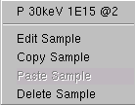
No sample ID edited
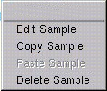

The Edit Sample_ID dialog box
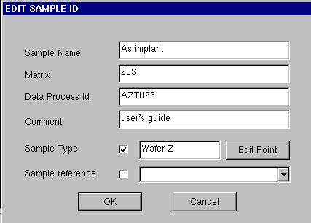

Procedure to edit a Sample_Id:
- click right on the target window in the synoptic,
- Select Sample_ID in the menu displayed,
- Fill the different editing fields (all are optional but Sample name)
- Click OK to validate the edition (or Cancel to abort the edition)

Sample Type files
These files are used in order to save the information relative to a type of samples. A type of samples is defined by :
- Alignments points
- The coordinates in the window axis system of the origin of the Sample axis system
- A series of analysis points defined with their coordinates in the Sample axis system.
Therefore a Sample Type file is mainly oriented to the definition of a sample with patterns.
In order to edit these parameters defining the sample type, the operator must open the Edit Sample Type dialog box by clicking on Edit point. This dialog box is shown in Figure 12
X, Y : editing field to enter the X&Y coordinate of a new analysis position. These coordinate are given in the Sample axis system.
Name : editing field to defined the name of the new position analysis position
Add : add to the list the analysis position being edited. Two analysis positions cannot have the same name. There is a prompt before overwriting a former point with the same name. Note that this function add the analysis point in the current list but not in the corresponding Sample Type File. A Save action is required in order to update the file
Delete : Delete the position selected in the list (the blue line)
Clear all : Clear the analysis position list
Goto : Click on this button to move the stage in order to bring the selected analysis position (blue line) onto the mass spectrometer axis.
Sample type file list : Display the name of the current Sample Type File on the top. Allow to select a new Sample Type File.
Load : Click on this button to load the Sample Type File display selected in the list
Save : click on this button to save the modifications of the current analysis positions series in the last loaded file. The previous file will be overwritten with no confirmation prompt.
Save as : click on this button to save the current analysis positions series in a new file. file. There is a prompt to enter a new file name.
Edit alignment : click on this button to open the dialog box for the edition the reference Alignment points (see § Sample alignment).

Figure 13: Edit Sample Type dialog box
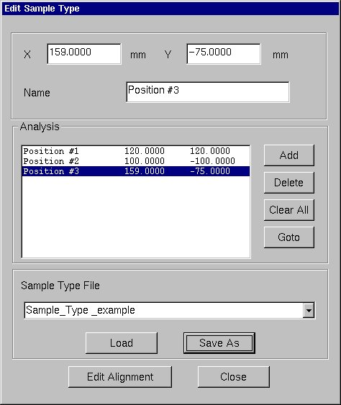

Sample alignment

Principle
Analyses in patterned samples in automatic mode require a control of the stage motion with an accuracy good enough to ensure a crater centering in the targeted pattern. This positioning accuracy depends on the relative alignment of the Stage Axis system and the Sample Axis system (see § Analysis position coordinates – Axis systems). The Sample Alignment and Holder Alignment tool allows to measure this relative misalignment and to apply a software correction for compensating it.
A sample alignment operation requires :
- To edit the coordinates of two reference Alignment points A and B in the Sample Axis system : (Xa_{th} ,Ya_{th}) and (Xb_{th} ,Yb_{th})
- To experimentally determine the coordinates of the A and B (Xa_{exp} ,Ya_{exp}) and (Xb_{exp} ,Yb_{exp})
Then, the program computes both the translation and the rotation of the sample with respect to the stage and derives the corrected coordinates (X_{cor} ,Y_{cor}) of any point from its nominal coordinates (X_{th} ,Y_{th})

Edit Alignment points
The measurement of the coordinates X_{exp} and Y_{exp} of a reference Alignment point requires to look for the reference pattern on the optical image of the sample surface, to center it on the reticule representing the mass spectrometer axis and to read the X and Y stage positions. There are two modes for completing this measurement :
- manual mode : in that case the operator manually center the pattern image on the mass spectrometer axis by using the Navigator program commands and/or the thumbwheels of the dedicated keyboard.
- Automatic mode : the Navigation software brings the pattern in the field of view of the optical microscope. A pattern recognition system automatically determined the stage position which would correspond to the centering of the pattern on the mass spectrometer axis. Note that this mode is available only when the instrument is equipped with the Pattern Recognition accessory.
The edition of the X_{th} and Y_{th} values of the 2 Alignment points is achieved in the dialog box shown in Figure 13.
Figure 14: Alignment points edition dialog box
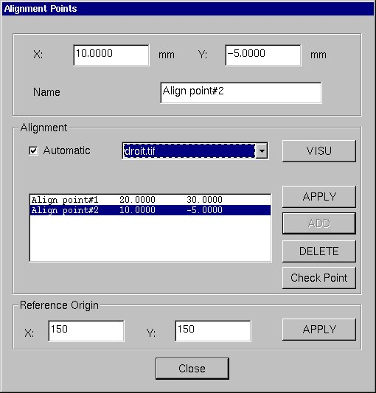
Selected pattern image
Selected alignment point
X, Y : editing field for the XY position of the alignment point
Name : editing field for the name of the alignment point
Automatic : must be checked in order to run the alignment operation with the Pattern Recognition system.
Pattern list : if the automatic mode is checked, the operator must select in this combo box the pattern which will be used by the Pattern recognition system to perform the alignment.
Visu : click on this button in order to display the image of the selected alignment pattern.
Apply : in the automatic mode click on this button to associate the selected pattern image with the selected alignment point.
Add : click on this button to add the edited alignment point to the list. This function is no longer available when there are already 2 alignment points in the list.
Delete : click on this button to delete the alignment point selected (blue line) in the list.
Check point (optional) : click on this button in order to add a third point in the list. This point will be used for the control of the alignment.
Reference origin (optional): during the alignment procedure (see § Tool>Sample alignment), the stage moves in order to bring the Alignment points within the field of view of the optical microscope. Before completing the alignment, if there is an offset between the Window axis system and the Sample axis system larger than the microscope image field of view, the alignment pattern will be set out of the field of view. In order to overcome this problem, the operator must enter the approximate offset (± 1mm) between the Window axis system and the Sample axis system.

Tools > Sample Alignment
This function is used to perform the alignment of a sample. This function can be activated only if Alignment points have been defined for the considered sample (see § Edit Alignment points)
When this function starts the dialog box shown in Figure 14 opens .
Figure 15: Sample Alignment edition dialog box
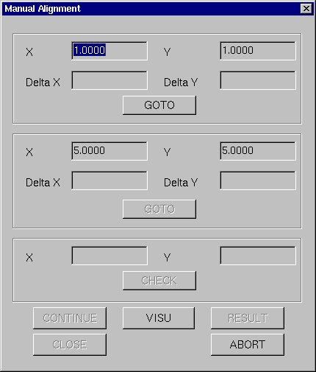
X, Y : display of the theoretical XY position of the alignment points
Delta_X and Delta_Y : display of the offsets between the theoretical and experimental coordinates along X and Y axis.
Goto : click on this button to move the stage to the theoretical XY position of the alignment points
Check : click on this button to move the stage to the theoretical XY position of the checking point (see § Edit alignment points)
Visu : click on this button to display the image of alignment pattern
Continue : click on this button to validate the stage position. Delta_X and Delta_Y are computed and the next alignment point becomes available.
Close : click on this button to validate the alignment and close the dialog box.
Abort : click on this button to abort the alignment procedure and close the dialog box.
Procedure to align a sample in manual mode :
  - Move to the sample to be aligned.
  - Edit the alignment points (see § Edit alignment points)
  - Select Tools>Sample alignment>manual
  - Click Goto for the 1st point
  - Check that the alignment pattern appears in the field of view of the optical microscope image. If not check, the Holder alignment (see § Holder alignment) and the Reference origin parameters (see § Edit Alignment points).
  - Move the stage in order to center the alignment pattern onto the reticule representing the mass spectrometer axis.
  - Click on Continue. The delta_X and Delta_Y values for the 1st point are displayed.
  - Click Goto for the 2st point
  - Move the stage in order to center the alignment pattern onto the reticule representing the mass spectrometer axis.
  - Click on Continue. The delta_X and Delta_Y values for the 2nd point are displayed.
  - Click on Results to check the results of the alignment procedure (optional)
  - Click on Check to control the alignment. If it correct the check point will be just on the mass spectrometer axis at when the stage stops.(optional)
  - Click close to validate the alignment of the current sample.

Holder alignment
The procedure for sample alignments is described in § Sample alignment. It requires to bring reference test patterns within the field of view of the optical microscope. Then the operator, or the pattern recognition system, can proceed to the sample alignment. This operation can be executed in automatic mode only if the total mis-alignment of the sample relative to the stage (resulting of loading operations Sample to Holder plus Holder to Stage) does not exceed the size of the field of view. To comply with this constraint it can be required to align the Holder on the stage first.
Like for a sample alignment, an holder alignment operation requires
- define the reference pattern (see § Holder edition(Edit alignment)
- Align the Holder (see § Tool>Holder alignment)

Tool > Holder Alignment
This function is used to perform the alignment of the holder. This function can be activated only if Alignment points have been defined for the considered sample (see § Holder edition(Edit Alignment).
The command are the same as for the Sample Alignment function (see § Tool>Sample Alignment).
Procedure to align an holder in manual mode :
  - Load the holder.
  - Edit the alignment points
  - Select Tools>Holder alignment>manual
  - Click Goto for the 1st point
  - Check that the alignment pattern appears in the field of view of the optical microscope image. If not check, the Reference origin parameters.
  - Move the stage in order to center the alignment pattern onto the reticule representing the mass spectrometer axis.
  - Click on Continue. The delta_X and Delta_Y values for the 1st point are displayed.
  - Click Goto for the 2st point
  - Move the stage to center the alignment pattern onto the reticule representing the mass spectrometer axis.
  - Click on Continue. The delta_X and Delta_Y values for the 2nd point are displayed.
  - Click on Results to check the results of the alignment procedure (optional)
  - Click on Check to control the alignment. If it correct the check point will be just on the mass spectrometer axis at when the stage stops.(optional)
  - Click Close to validate the alignment of the current holder.

Holder>load
This function is used in order to define the current sample holder which is the holder loaded in the analysis chamber. This is a software definition only and the holder will have to be physically loaded by the operator.
Procedure to load a Holder
- Select Holder>Unload. The stage moves to the Load/Unload position
- Check with the optical microscope that the stage is well set in the Load/Unload position.
- Physically unload the holder from the stage and load the new holder from the airlock into the analysis chamber.
- Select Holder>Load. The Holder list dialog opens. Select in the list the holder file name corresponding to the holder loaded in the analysis chamber.
- Click OK, the schematics of the holder appears in the synoptic window.
Note that a Holder file is loaded in the Navigator software with its associated Sample configuration and Preset position files. Afterwards, using the Load function for Sample configuration and Preset positions files, a given holder can be associated with different sample and preset position configurations.

Holder>unload
This function is used in order to unload the Holder from the stage. The Unload command moves the stage to the Load/Unload position but the holder will have to be physically unloaded by the operator.
Procedure to unload a Holder
- Select Holder>Unload. The stage moves to the Load/Unload position. The synoptic shows an empty stage.
- Check that the stage is well set in the Load/Unload position.
- Perform the holder load/unload operation between the stage and the airlock.
When the Unload command is applied all the modifications made for the Sample configuration and Preset Positions are saved in their respective current file name.

Edit Holder mode
This mode is used by the operator to define the Holder to be used on the instrument. The operator can :
- Edit a new Holder configuration, i.e. definition of the position and the size of the windows for the holder.
- Edit the Sample ID (definition of the sample ID for every window)
- Edit Preset positions (preset positions are stage positions that the operator wants to memorize in order to be able to come back on it by a single command).
- Save a new Holder configuration
- Duplicate an holder definition
- Modify an already existing Holder configuration
- Delete an Holder definition
- Restore the last Holder deleted

Main commands
The operator can handle the Holders by selecting the following commands in the Holder menu :
New : to create a new Holder. The Edit Holder dialog automatically open (see § Holder configuration edition)
Modify : to modify an already defined Holder configuration (cannot be used for the current holder).
Save as : to save the present Holder with a new name
Duplicate : to copy an Holder configuration with a new name (cannot be used for the current holder).
Delete : to delete the Holder selected in the list (cannot be used for the current holder).
Restore : to restore the last Holder deleted
Sort : to modify the list order of the Holder names.

Holder configuration edition
This edition is divided in 3 different steps :
- Holder configuration (window layout in the holder)
- Sample configuration (which sample in which window)
- Preset positions (memorized positions over the useful area of the sample holder)
The operator activates one of these 3 edition modes by clicking on one of the 3 tabs (Holder, Sample_ID, Preset position).
During the edition, there is a synoptic of the Holder presently edited which is updated according to the configuration under definition.
The available commands are :
Front / Back : the label of this button indicates the representation mode of the holder in the synoptic. The toggle between the Front/Back representation is made by clicking on this button. The representation change is made by means of a symmetry relative to the horizontal axis of the figure.
Click on these buttons to change the present window selection . (: previous, : next,  : first one)
OK : close the Edit Holder window. All the modifications edited in the different menus (see § Holder edition) are automatically saved in their respective files(Holder, Sample configuration, Preset positions). If new file name(s) has(ve) been edited in the editing fields, OK command is equivalent to the Save as command.
Cancel : click Cancel to close the Edit Holder mode. None of the modifications edited in the different menus are saved.
Figure 16: Holder edition, window configuration
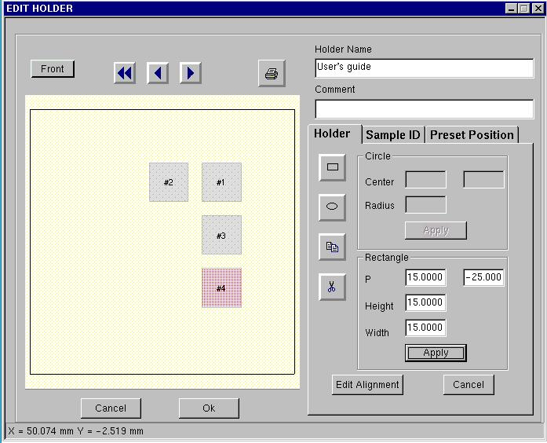

Holder edition (window configuration)
The Holder editor allows the operator to define the window configuration of a given holder. This window configuration is graphically represented in the synoptic during the edition procedure.
The available commands are :
 : to toggle in the edition mode of rectangular (squared) window
 : to toggle in the edition mode of circular window
 : to paste a window
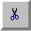 : to cut a window
Copy : to copy a window
Delete : to delete a window
Center : editing fields for defining the X and Y coordinates of the centre of a circular window. The zero of the XY coordinate system is the centre of the holder.
Radius : editing field to define the radius of a circular window.
P : editing fields for defining the X and Y coordinates of the lower left corner of a rectangular window. The zero of the XY coordinate system is the centre of the holder.
Height : editing field for defining the height of a rectangular window
Width : editing field for defining the height of a rectangular window
Edit alignment : command to open the dialog box used to define the alignment point of the Holder under edition.
Procedure to edit a window :
- Select either Holder>New (for a new holder definition) or Holder>modify (for modifying an already existing holder). In the former case select in the list the holder to be modified.
- Select the Tab Holder. Select the type of window to be added (rectangular or circular)
- Edit an Holder name to save all the information
- Edit the position and the size of the new window
- Click Apply. The new window is displayed in the synoptic. Note that the software does not allow the overlay of two windows. If it happens there is a prompt asking the operator to modify the Center or P values.
Note : the windows are numbered according to their edition order.

Procedure to copy a window :
- Select a window type (rectangular or circular) identical to the window to be copied. Editing fields for the window definition are empty.
- Click right on the window to be copied and select Copy
- Click on the Paste icone. The parameters of the copied window are displayed in the parameters of the new window
- Modify P (or Center) parameters in order to avoid window overlay.
- Click Apply. The new window is displayed in the synoptic.

Procedure to delete a window :
- Click right on the window to be removed
- Select Delete. The window is erased in the synoptic

Holder edition (edit alignment)
The dialog box to edit the Holder alignment parameters offers the same commands as for the Sample alignment (see § Sample alignment).
The defined parameters are saved at the same time the window configuration.

Sample ID edition
The sample edition in the Edit Holder mode is the same as in the Navigator window (see § Sample ID editor).
The edition performed in this menu are saved in a file with the name displayed in the combo Configuration Sample File. For a new holder, the default file name is the holder name.
Figure 17: Holder edition, Sample ID
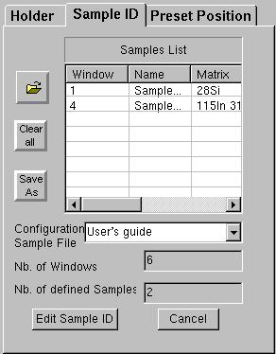

Preset Position edition
The sample edition in the Edit Holder mode is the same as in the Navigator window (see § Sample ID editor).
The edition performed in this menu are saved in the preset position file with the name displayed in the combo Preset position. For a new holder the default file name is the holder name.
Figure 18: Holder edition, Preset position
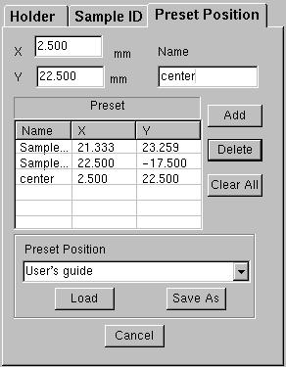

Crater position list
For every analysis launched form the Analysis program, the Navigator program stores information in a file which can allow the operator to control the relative crater position for different analyses on a given sample. Note that all craters sputtered outside of the Analysis program are not considered by this function.
The command Sample>crater in the Sample menu opens a dialog box which lists this information. This dialog box is shown in Figure 19.
Figure 19: Crater position dialog box
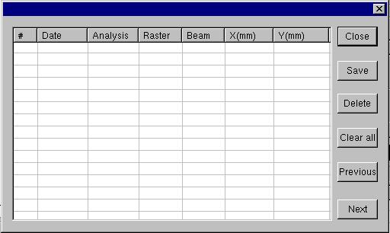
# : Analysis rank. Note that the maximum number of analysis per sample is 50.
Date : date of the analysis
Analysis : Analysis type (Depth profile, mass spectrum….)
Raster : raster size used for the analysis
Beam : spot size in the case of the use of a static primary beam (raster = 0µm)
X(mm) and Y(mm) : X and Y coordinates of the analysis position in the stage axis system.
Close : to close the dialog box
Save : to save the crater position list.
Delete : to delete a line in the list
Clear All : to get an empty crater position list.
Next/Previous : in order to move back and forth in the list. When a crater (i.e. a line in the list) is selected, the corresponding symbol representing the crater in the synoptic (see § Sample holder synoptic) turns to a different color in order to identify it.

Tools

Init stage
This command is used when a mis-agreement appears between the analysis position requested by the operator and the actual stage position. This problem can be due to a loss of the initialization of the stage.
The Init stage command takes about 1-2 minutes to be completed. The two axes (X and Y) are initialized. At the end of the procedure the stage returns to the position 0,0.

Logbook
The Navigator program updates the content of a logbook after every analysis completed. The Logbook dialog box opens with the command Tools>Logbook. In this logbook, the operator can read the following parameters :
Date : completion date of the analysis
Window : window number where the sample is loaded in the holder
Point : analysis point number (see § Sample type file)
X(mm), Y(mm), Z(µm) : analysis position coordinates
Sample : sample name
Data file : name of the raw data file saved at the end of the analysis.
Holder : holder name
Preset file : preset position file name associated to the holder
Pattern file : Pattern file name associated to the sample
There are commands to handle the content of the logbook :
Sort : this combo offers the choice between criteria to sort the information listed in the logbook (Date, holder name, Analysis type, Sample name, Data file name)
Save : to save the content of the logbook in a dedicated file
Print : to print the content of the logbook.
Previous/next : in order to move back and forth in the logbook list. When an analysis (i.e. a line in the list) is selected, the corresponding symbol representing the crater in the synoptic (see § Sample holder synoptic) turns to a different color in order to identify it.
Close : to close the Logbook dialog box.
Figure 20: Logbook dialog box
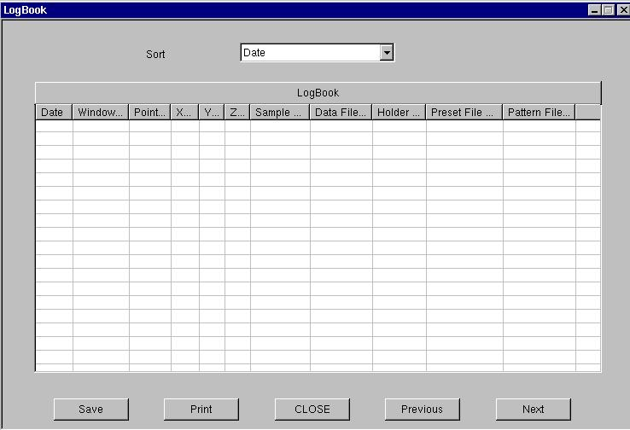

Setup file parameters
The hereunder table summarizes the parameters which must be defined in the Set-up program in order to run the Navigator program for a given instrument
They can be defined in the set-up menu Setup>Software>Holder. Note that they correspond to factory setting and the operator does not change them unless the instrument hardware configuration has been changed.
N° | Parameter name | Function
86 | STP_ID_IMS_TYPE | Instrument type
619 | STP_ID_HOLDER_OFFSET_X | Offset for X coordinate
620 | STP_ID_HOLDER_OFFSET_Y | Offset for Y coordinate
700 | STP_ID_X_LOAD_UNLOAD_POS | X position of the stage for the holder extraction from the analysis chamber.
701 | STP_ID_Y_LOAD_UNLOAD_POS | Y position of the stage for the holder extraction from the analysis chamber.
702 | STP_ID_X_LOAD_UNLOAD_DELTA | Precision on the X position of the stage for the extraction from the sample chamber
703 | STP_ID_Y_LOAD_UNLOAD_DELTA | Precision on the Y position of the stage for the extraction from the sample chamber

